Name _______________
IRAT
INDIVIDUAL READINESS ASSURANCE TEST
Session #13: Meta-analysis
4-28-14

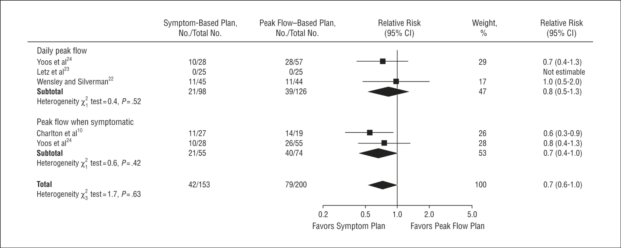

- The figure above represents a Forest Plot. The measure used is the relative risk (RR). What do the characteristics of the diamond represent?
  - The size of the diamond represents the number of patients in the total group
  - A line drawn through the vertical center of the diamond represents the 95% CI
  - A line drawn through the vertical center of the diamond represents the summary RR
  - The size of the diamond is proportional to the size of the study with the fewest patients

 | Outcome
Exposure | + | -
+ | A | B
- | C | D

- Please note the 2X2 table above. What is relative risk?
  - [A/A+B]/[C/C+D]: the ratio of the odds of the events in the intervention to that in the control group
  - [A/A+B]/[C/C+D]: the ratio of the prevalence of the events in the intervention to that in the control group
  - [A/A+C]/[B/B+D]: the ratio of the odds of the events in the intervention to that in the control group
  - [A/A+B]/[B/B+D]: the ratio of the prevalence of the events in the intervention to that in the control group

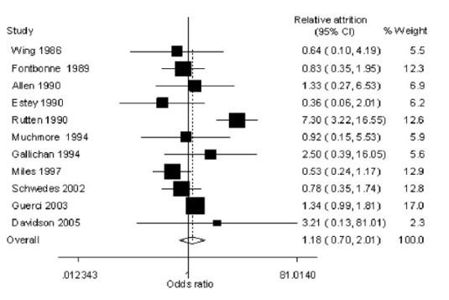

- Please note the figure above. What is the meaning of the size of the boxes?
  - The size of the boxes are proportional to the precision of the study (roughly the number of patients)
  - The size of the boxes are proportional to the effect size of the individual studies
  - The size of the boxes are proportional to the 95% CI of the individual studies
  - The size of the boxes are proportional to the inverse of the size of its contribution to the total meta-analytical effect size

(PLEASE TURN OVER FOR THE NEXT 2 QUESTIONS)

IRAT (continued)
INDIVIDUAL READINESS ASSURANCE TEST
Session #10: Meta-analysis
4-28-14

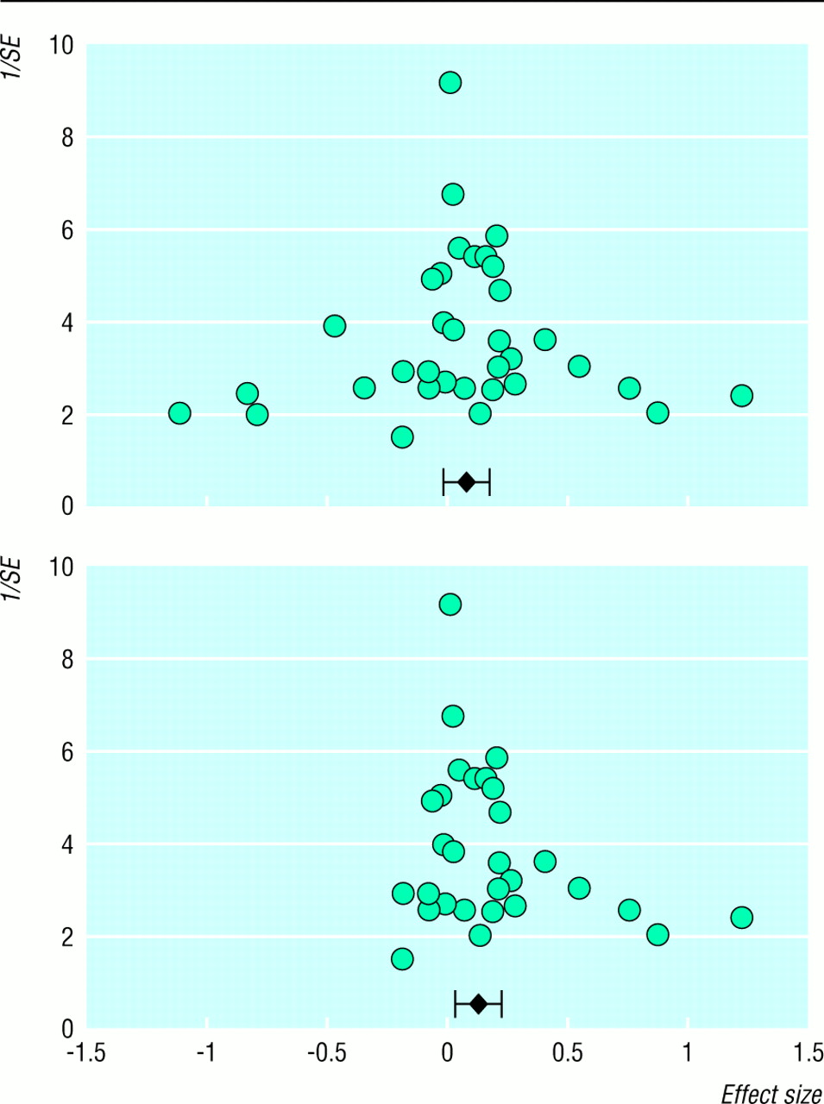

- Publication bias is a systematic attempt to limit the publication of negative studies (studies that do not find a benefit of the new treatment). They are less likely to be published than those that conclude that the treatment is effective. The figure above is a Funnel Plot, a pictorial representation to detect publication bias. The individual studies of a meta-analysis are plotted on a graph with the y-axis the sample size and the x-axis the effect size. Smaller studies are more likely to have variability based on chance. Is there evidence of publication bias?
  - The upper graph suggests publication bias, as the studies appear remarkably symmetric around the summary effect size
  - The lower graph suggests publication bias, as there appears to be fewer smaller studies represented in the area of negative effect of treatment than would be expected by chance
  - Both graphs suggest publication bias, as studies are missing at the top of the y-axis where significant variability would be expect by chance
  - The upper graph suggests publication bias, as there appears to be more smaller studies represented in the area of negative effect of treatment than would be expected by chance

- From time-to-time, a large-scale, well-conducted, randomized controlled trial (RCT) will be published subsequent to a meta-analysis on the exact same topic, and the new study will contradict the conclusions of the meta-analysis. Pick the BEST answer as to why this may have occurred?
  - The RCT may be too large, suggesting a clinically-meaningful effect
  - The meta-analysis is actually correct, as it reports the aggregated results of multiple studies, as opposed to the results of a single study
  - The RCT may be flawed in ways that are completely undetectable
  - The meta-analysis may be flawed due to the variable quality of the included studies (the “GIGO” principle – garbage in, garbage out)

