APPLICATION EXERCISE
Session #13
4-28-14
Meta-analysis

In the systematic review by (Zemek, et al. 2008) in the methods section of this study, the authors wrote: “With all the studies published… sensitivity analyses examining publication bias [was] irrelevant.”

- Assume that the authors completed a typically thorough search for studies related to the question. Pick the BEST statement.
  - This is a logical approach to detect publication bias as the authors completed a thorough search
  - Publication bias refers to funding source bias (e.g., makers of peak flow meters sponsored the research) and thus the authors are suggesting that funding was independent of possible conflict of interest
  - Publication bias refers to the number of negative studies. As both negative and positive studies were found, there cannot be publication bias related to this meta-analysis
  - Publication bias refers to the decreased likelihood that negative studies are published. Thus the statement of the authors appears fundamentally incorrect

- Subsequent to this systematic review/meta-analysis, 2 RCT’s have been published – the first was an ED-based study (Ducharme, et al. 2011), where the patients were randomized to receive an asthma action plan or not, following a visit to the ED for an acute exacerbation

Ducharme, et al. 2011
 | Written Action Plan (n = 109) | No Action Plan (n = 110) | Relative Risk (95% CI)
Subjects with ≥1 acute care visits | 10 (9%) | 8 (7%) | 1.27 (0.52, 3.10)

The corresponding ARR = 2% [-5, 9].

- The other RCT, a study clinic-based study (Wong, et al. 2012), compared a written asthma action plan to no plan
Visit to ED/Clinic
 | Control n=23 (%) | Study n= 37 (%)
No | 32 (81.6) | 33 (89.2)
Yes | 6 (21.1) | 4 (10.8)

The corresponding ARR = 5% [-10, 20].

APPLICATION EXERCISE (continued)
Session #13
4-28-14
Meta-analysis

- You want to be 95% confident that a written asthma action plan will generate a 10% benefit on the frequency of a subsequent acute care asthma visit. Given the results of the 2 RCT’s above
  - The Ducharme, et al., study rules out a clinically significant benefit, while the Wong, et al., study does not
  - The Ducharme, et al., study rules in a clinically significant benefit, while the Wong, et al., study does not
  - Neither the Ducharme, et al., study nor the Wong, et al., study rule out a clinically significant benefit
  - The Wong, et al., study rules in, while the Ducharme, et al., rules out a clinically significant benefit
- In a third study, a systematic review/meta-analysis (Zemek, et al. 2008) evaluated the literature on the above question with the primary outcome measure being the number of patients with at least one acute care visit after being given the asthma action plan. One clinic-based study compared a peak-flow-based plan to no plan and found a statistically significant difference in favor of the plan. [There were four other clinic-based studies which compared a symptom-based plan to a peak-flow-based plan.]

- A fourth study was a hospital-based, cross-sectional study of 30 children’s hospitals and 37,267 children admitted with asthma (Morse, et al. 2011). The study looked at what they felt was a clinically meaningful improvement (5%) in compliance with the Joint Commission Children’s Asthma Care measure set which includes a written asthma action plan prior to discharge (CAC-3 = Children’s Asthma Care measure ⬄ the asthma action plan, in the table below), and its association with subsequent ED utilization and readmission rates for asthma

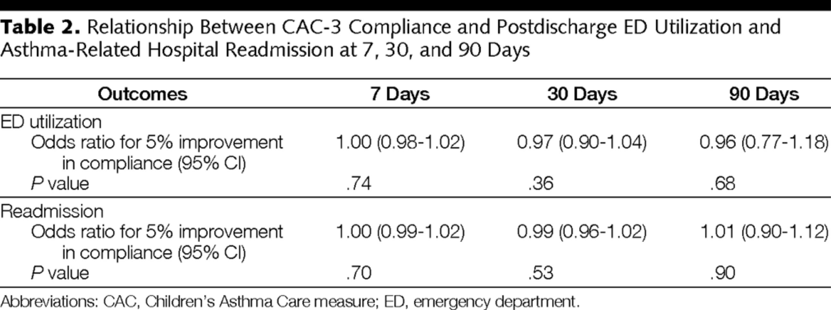

The corresponding ARR at 30 days post-discharge (with a baseline ED utilization of 7.3%) = 0.2% [-0.7, 0.3].

- You note that this third study was not an RCT. However, it included more than 37,000 patients and linked each patient to asthma-related ED use and re-hospitalization. Asthma action plans are only one part of asthma education. However, 1) when considered in isolation, 2) given the data of the 4 studies listed above, and 3) assuming a clinically meaningful benefit of 10%, are asthma action plans clinically effective in preventing a subsequent acute care visit?
  - Overall, asthma action plans are not effective in preventing acute care visits for exacerbations
  - Overall, asthma action plans are effective in preventing acute care visits for exacerbations
  - Overall, hospital discharge asthma action plans are less clinically effective than clinic-based plans
  - Overall, hospital discharge asthma action plans are more clinical effective than clinic-based plans

