Name _______________
IRAT
INDIVIDUAL READINESS ASSURANCE TEST
Session #11: Review of Sessions 3-10
3-14-14

- The Clinical Queries feature of PubMed offers the following enhancement to PubMed searching:
  - It converts search terms to MeSH headings and searches both NLM and European medical literature databases
  - It automatically calculates the basic EBM statistics (LR, NNT); however, 95% CI’s are not calculated
  - Database searching is limited to English-language literature (broadly defined) and only those articles with EBM-type statistics listed in the abstract (ARR, NNT, LR)
  - Methodologic quality filters are appended to the search terms to identify the most methodologically sound articles

- The basic difference between the ARR and the post-test probability is
  - The ARR is the probability of a patient benefiting from the new therapy; the post-test probability is the probability of disease following administration of a test
  - The ARR is the probability of achieving the defined favorable outcome; the post-test probability is the a priori probability of contracting the defined disease
  - The ARR is the probability that unfavorable disease outcomes will be reduced compared to those who do not receive the therapy; the post-test probability is the opposite
  - The ARR refers to how many patients one must treat for one patient to derive benefit from the new therapy; the post-test probability is disease probability in those treated with placebo

- The LR differs from NNT in that
  - The LR is not only the inverse of the NNT but also refers to a property of diagnostic tests as opposed to therapeutic benefit – defined by the NNT
  - The LR is an intrinsic property of a diagnostic test, unaffected by disease prevalence; the NNT is an intrinsic property of the novel therapy, unaffected either by the control or experimental event rates
  - The LR describes the probability that a diagnostic test will be positive among patients with the disease; the NNT is the probability that a patient will derive benefit from a novel therapy among patients with the disease
  - The LR is the probability that the patient comes from the diseased rather than the healthy population; the NNT is the number of patients one must treat to see one patient benefit from the novel therapy

- Compared to the placebo group, children in the lactobacillus group had a significantly reduced risk of upper respiratory tract infections, ARR 21% [10, 25%]. Pick the set of data that correlate BEST with this ARR and its 95% CI.
  - CER/EER/NNT: 0.436/0.415/5 [2, 12]
  - CER/EER/NNT: 0.650/0.440/4 [2, 12]
  - CER/EER/NNT: 0.436/0.215/4 [4, 10]
  - CER/EER/NNT: 0.650/0.440/5 [4, 10]

- A study was performed to see how well bedside ultrasound could diagnose intussusception, as compared with the gold standard of diagnostic radiology. 20% received a diagnosis of intussusception by diagnostic radiology. Bedside ultrasonography had a sensitivity of 80% and a specificity of 80%. What are the +LR, -LR and post-test probabilities of intussusception for both a positive and negative test
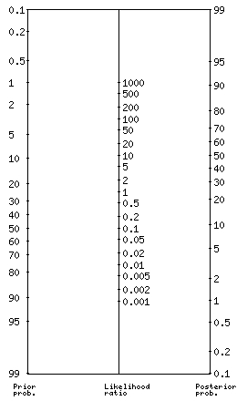

- 1/0.1/90%/10%
- 4/0.25/50%/5%
- 1/0.1/50%/5%
- 8/0.25/65%/5%

